
DAILY HOMEWORK

GRADE: - X

SUBJECT
SST | Write questions and answers of chapter Money and Credit from PW Module
English | - Write questions and answers of Amanda from DPP Booklet no.3.  - Learn phrase and meanings for Analytical paragraph.  - Q.4. Gurmeet Kaur is an aspiring candidate for a public-funded engineering college in the suburbs. She belongs to a nearby village, has minimal technological skills and exposure, has the required cut-off percentage and is looking for a complete or partial scholarship.  Write a paragraph in about 100-120 words, analysing her SWOT notes to support your stand on whether she should join/not join the college.  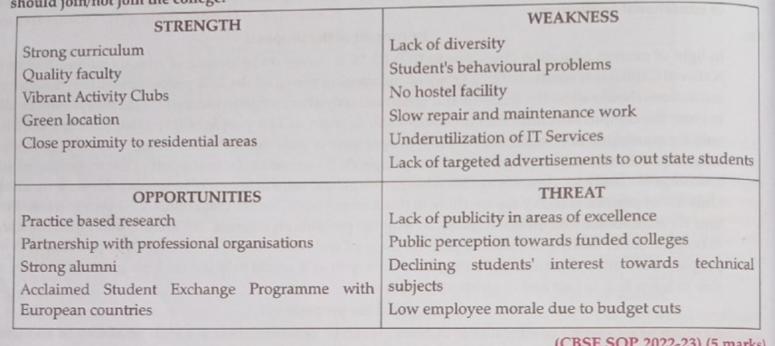  In support of the decision  The given information illustrates the options that Gurmeet would weigh in order to take the right decision about her admission in a public-funded engineering college. With availability of strong curriculum, quality faculty and vibrant Activity Clubs, she will be assured of an enriching educational journey Though hostel facility is unavailable, she may take up accommodation in the suburbs or choose to travel daily from her village. Good opportunities of practice-based research, partnership with professional companies and international students exchange program will enhance her professional and interpersonal skills. Hard work, responsible behaviour and prudent decision-making could help Gurmeet thrive in the college even though it has a rigid and conventional culture. The strengths and opportunities work in favour of Gurmeet. Taking this opportunity will allow her to mend the incorrect public perception towards public-funded colleges and students outlook towards technical subjects.  Against the decision  The given information indicates Gurmeet's dilemma about seeking admission in a public- funded college. Though equipped with a strong curriculum, engaging activity clubs and an able faculty, the college lacks diversity and good conduct among the students, giving rise to concerns of safe environment for a novice like Gurmeet. Under utilisation of IT services will be further detrimental to the progress of Gurmeet's educational journey and add to extra costs related to research work. If she does not qualify for a complete or partial scholarship, arrangement of own accommodation and additional expense of students exchange programme will increase her expenditure, too. Such a college environment may dampen her endeavouring spirit. The weaknessand threats outweigh the strengths, in case of Gurmeet. So, it is recommended that Gurmeet does not apply for admission to the said college.
DAY: - MONDAY DATE: - 22-09-2025

